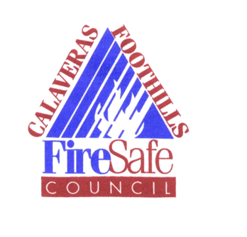

Calaveras Foothills Fire Safe Council
P.O. Box 812 Murphys, CA 95247

April 20, 2017 Regular Meeting 6:00 PM
Murphys Fire Training Room,
Main Street and Jones Street, Murphys CA

- Call Meeting to Order
- Introductions
- Discussion: Bruce Lodge Presentation
- Approval of Minutes from March
- Financial Report

OLD BUSINESS:

- Discussion/Action: Grant Report

  - General Grants

NEW BUSINESS:

- Next meeting May 18, 2017
- Public and Board Member Comment
- Adjournment

Phone: 209-728-8785
E-mail: info@calaverasfiresafecouncil.org

