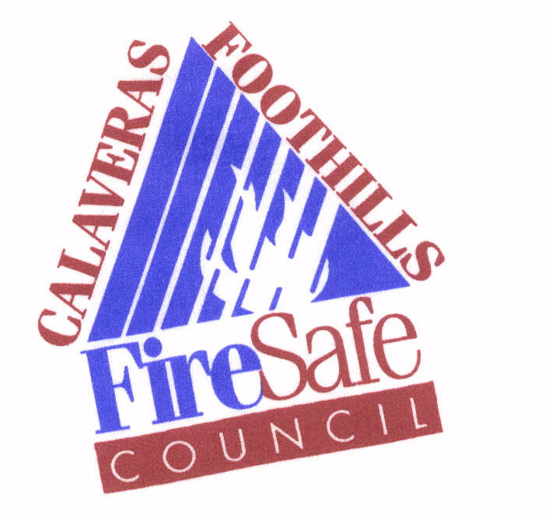
Calaveras Foothills Fire Safe Council
P.O. Box 812
Murphys, CA 95247

2024 Application for the Seniors and Disabled Defensible Space Program

Sponsored and funded by the
Calaveras Foothills Fire Safe Council and P.G.&E.

Name(s) of property owner(s) ______________________________________________

Street Address: __________________________________________________________

Email: _______________________________ Phone: _______________________

California requires clearance of 100’ from a structure or to the property line (Public Resources Code 4291). This minimum is required to protect your home in the event of a wildfire. In some cases, based on the fuel type, topography and weather conditions, 100 feet of clearance may not be sufficient to protect your home. It is still the homeowner’s responsibility to comply with California State Regulations.

The Calaveras Foothills Fire Safe Council will hire a contractor to conduct a pre-work inspection as well as schedule and perform the 100 foot clearances around your home. The contractor will rake, weed-eat, remove brush and limb up trees from around your home. The contractor will not clean roofs or gutters. Tree removal will be the responsibility of the homeowner.

Hold Harmless: I/we understand that P.G.&E. and the Calaveras Foothills Fire Safe Council is helping me/us clear around my home to assist with compliance with Public Resources Code 4291. I/we, the landowner(s), shall not hold P.G.&E., the Calaveras Foothills Fire Safe Council or the contracted service providers responsible for any damage to property or injury to persons that may arise out of the work performed or that may result from a wildland or other fire.

I/we shall defend and hold the Calaveras Foothills Fire Safe Council, P.G.&E. and their designated contractor(s), their officers, board of directors, members and their employees harmless against and from any and all claims, suits, losses, damages and liability for damages of every name, kind and description, including attorney’s fees and costs incurred, brought for, or on account of damage to property, or any economic or consequential losses which are claimed to, or in any way arise out of, or are connected with, P.G.&E., the Calaveras Foothills Fire Safe Council or employees of any of these or their designated contractors, except as expressly prohibited by statute. I authorize members of the Calaveras Foothills Fire Safe Council, their contractors and agents right of entry onto the property identified in this document.

By signing this agreement, you affirm that you are: age 60 or over or physically unable to perform the work yourself. All owner(s) listed on the deed for the property listed above must sign below.

Owner: ___________________________________ Date: ________________________

Owner: ___________________________________ Date: ________________________

If applicant(s) is/are incapable of filling out this form, name of person on behalf of the applicant: ______________________________________________________________

In my opinion this/these nominee(s) is/are both physically incapable of performing the work or are over the age of 60.

Signature: _________________________________ Date: ________________________

Email: ____________________________________ Phone: ______________________

Please email or mail completed and signed application to: info@calaverasfiresafecouncil.org or P.O. Box 812, Murphys CA 95247

